Image processing final lab


Names : Mohamed Yasser 200047921
yassin hany 200039172
Shahd Mohamed 200039171
Merna hesham 200043852
Introduction
In computer vision, image quality plays a major role in how accurately a system can understand and analyze visual data. However, real-world images are often affected by noise, weak lighting, blur, or low contrast, especially when captured in difficult environments or with high ISO settings. These issues can reduce the effectiveness of computer vision models and make image analysis more challenging. Because of this, image preprocessing is an essential step before applying tasks such as object detection, recognition, or classification.
This project focuses on building an image preprocessing pipeline that improves the quality of noisy color images using several enhancement techniques. The pipeline combines Gaussian Blur to reduce noise, CLAHE to improve image contrast, and sharpening filters to make edges and details clearer. By applying these methods step by step, the project demonstrates how preprocessing can significantly improve the appearance and quality of images.
The project was implemented using Python with OpenCV, NumPy, and Matplotlib in Google Colab. Different noisy images were tested, and the results of each processing stage were displayed and analyzed using histograms. The overall goal of the project is to show how preprocessing techniques can help produce cleaner and more visually clear images for computer vision applications.

Abstract
This project presents an image preprocessing pipeline designed to enhance noisy color images. Many images captured in real-life conditions contain unwanted noise, low contrast, and unclear details, which can negatively affect computer vision performance. To solve these problems, the project applies a sequence of enhancement techniques including Gaussian Blur for noise reduction, CLAHE for contrast improvement, and sharpening filters for enhancing image details.
The system was developed using Python and OpenCV in Google Colab and tested on images with different noise levels. The results showed noticeable improvements in image clarity, contrast, and overall visual quality after preprocessing. Histograms were also used to compare the images before and after enhancement to better understand the changes in pixel intensity distribution.
This project demonstrates the importance of image preprocessing in computer vision and how combining multiple enhancement techniques can improve image quality and prepare images for further analysis tasks.
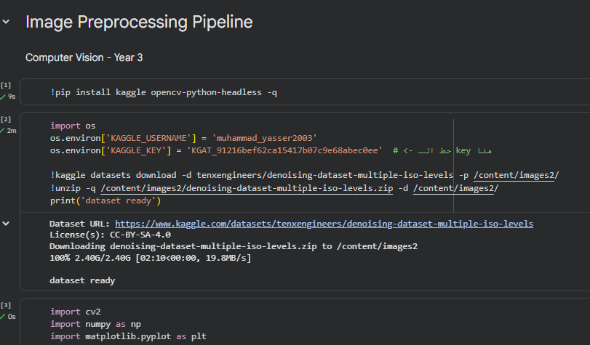
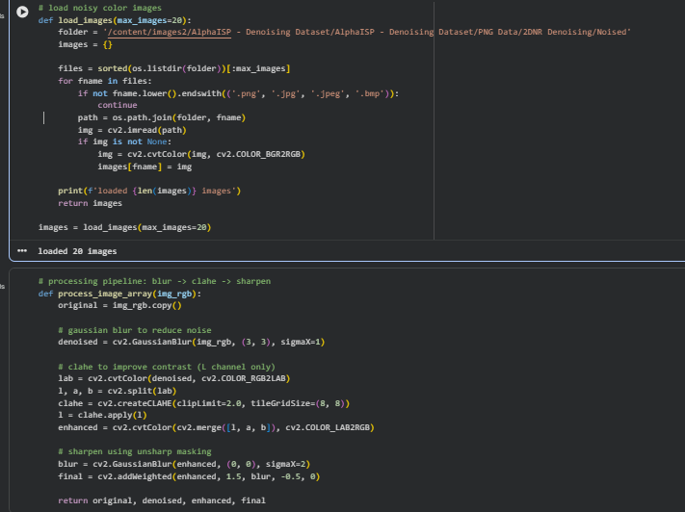
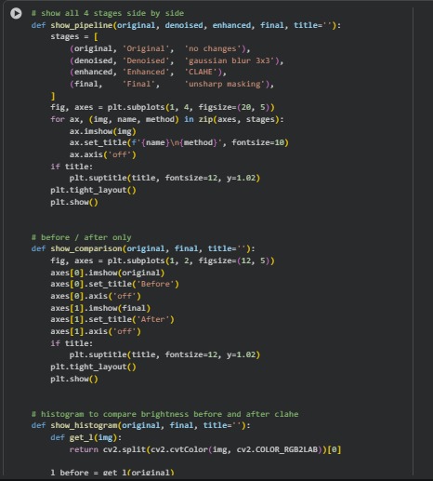
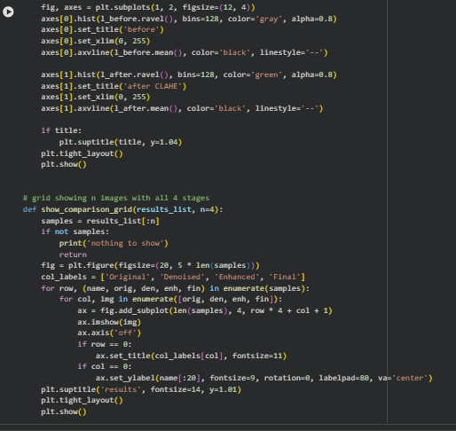
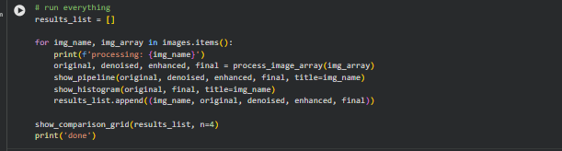
Output

